**Experiment 10**

**Objective:**  WAP to design a butterworth filter high filter using following specs:

Passband attenuation : 0.2db

StopBand Attenuation : 40db

PassBand Frequency : 2KHz

Stop Band Frequency : 3.5KHz

Sampling frequency: 8Khz

**Software used:** MATLAB 2016a

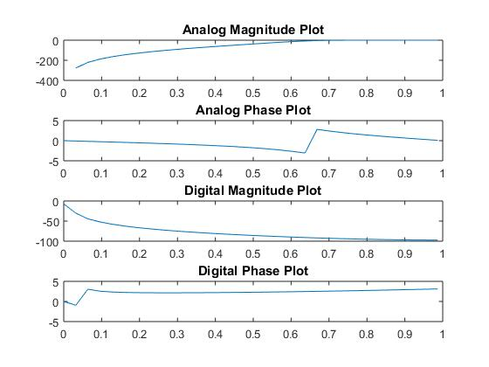

**Code**

pba = 0.2;

sba = 40;

sbf = 3.5;

pbf = 2;

sf = 8;

Wp = 2*pbf/sf;

Ws = 2*sbf/sf;

[n,Wn] = buttord(Wp,Ws,pba,sba);

[b,a] = butter(n,Wn,'high');

w = 0:0.1:pi;

h = freqz(b,a,w);

h1 = 20*log(abs(h));

p = angle(h);

subplot(4,1,1);

plot(w/pi,h1);

title('Analog Magnitude Plot');

subplot(4,1,2);

plot(w/pi,p);

title('Analog Phase Plot')

%Convert design analog filter into digital filter using impulse invariant

%transformation.

pba = 0.2;

sba = 40;

sbf = 3.5;

pbf = 2;

sf = 8;

Wp = 2*pbf/sf;

Ws = 2*sbf/sf;

[n,Wn] = buttord(Wp,Ws,pba,sba);

[b,a] = butter(n,Wn,'high');

w = 0:0.1:pi;

[bz,az] = impinvar(b,a,sf);

y = freqz(bz,az,w);

yabs = 20*log(abs(y));

pdig = angle(y);

subplot(4,1,3);

plot(w/pi,yabs);

title('Digital Magnitude Plot');

subplot(4,1,4)

plot(w/pi,pdig);

title('Digital Phase Plot');